**2013.10.03**

**SPP – ISIS – EPI-Hi – Mechanical Peer Review**

Attendees:

Sandy Shuman (SwRI)

Susan Pope (SwRI)

Scott Weidner (SwRI)

David Braun (JPL)

Tim Cole (JPL)

Mary White (JPL)

Chip Beebe (SwRI)

Craig Auletti (GSFC)

=====

We distributed the ICD draft to the spacecraft. This shows all of the Thermal Limits.

We are now going though the slides:

- are there any blind connections?

> Yes. In the telescopes, but they have guide pins

- how do you access the mounting hardware to the bracket?

@ top fastener (short side) is blocked by the LET2 telescope. Need to show clearances for tools at PDR

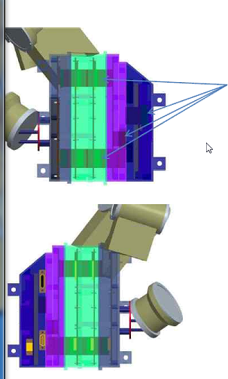

@ we need to check if the 303SS fasteners will pass on the M&P list. We can use A286 for most fasteners unless there is a size issue or a special head that is required.

- what torque requirements are used?

> GSFC has a torque spec. but it only covers #4 and up.

- Spacecraft Connectors are hardmounted to the PCB

> screwed to the board

> then reflowed

@ the DPU needs to have the two different types of connectors to a mounting fixture and then tie them to the PWB and then reflow. Otherwise, the two connector types may not be square and aligned in such a way that they will mount flush to the frame for a good EMI seal.

@ the frame that holds the DPU and the Bias Supply should be extended up to include the DPU connectors. They should NOT close out against the LVPS frame.

@ have the scientists agree that the drum-warping that you might see from differential thermal expansion will not affect the science measurement (make calculation before PDR).

- purge connector will be on the main box but will not purge the electronics. It will be routed with a Teflon hose up to the telescopes.

- concern about TRL6 vs TRL5 on the thin detectors

> similar mount configuration

> diaphragm in a tube is different than a diaphragm by itself.

> need to have combined load with thermal test

> need to test critical environment in a flight-like way

- Mass

> 20% contingency. That is an NTE

> hardware is included in the estimate

>

- What is dynamic clearance between boards

> there is an extra millimeter 0.040” if two tall components face each other.

> stiffeners flowed to PCB layout guys:

> ¾ mm of extra room with keep out zones

- voltage spacing between wirebonds is okay even when boards are back-to-front

- locking philosophy for fasteners

> will have to file a Gold Rule Waiver

> A286’s would be better for high torque

@ analysis required for bolted joint analysis. Do you need a pin to hold it in place?

- minimum number of threads engagement: 4 threads minimum

- are there any blind holes? Don’t think so, but if so we will vent them. Also recommend 5 threads in this case.

@ Bore-sight alignment requirement? Connect the dots with spacecraft folks

> need a budget and

@ Combined case of acoutstic and thermal load on the detector show that it is positive at launch (need to know launch temperature)

@ redundant load path for the board mounted connector. Thermal load will pull on the board. This is probably not supercritical but

@ Structural analysis – need it before PDR

@ M&P List – need it soon.